

NOVAC TECHNOLOGY SOLUTIONS

User Manual

Document Version No.: 1.00

Revision History
Version No | Reason For Changes | Author | Approver
0.01 | Draft | Anurag Kumar
1.00 | Reviewed & Approved the User Manual | Anurag Kumar | NIJANTHAN PL

Table of Contents
1. Introduction 4

2. Policy Schedule Interface screen 4
3. Claim Information 5

Introduction

As per the requirement, new changes are need to be added in Policy Schedule generation screen and the details are given below.

Policy Schedule Interface screen

- New input parameters are required in the Policy schedule printing interface screen to view the details of Policy information, Premium Computation, Transaction Information and Claim Information. System should provision to download the Transaction information details in excel format.
- Policy information, System should display the policy information in the view mode, which is same like as claim screen. Refer the below screen shot for reference.
- Premium Computation, System should display the premium computation details in this tab against the respective policy, which are displayed in the proposal screen. Refer the below screen shot.
- Transaction Information, System should display the transaction information of Receipt, Commission payment and Refund details in this transaction tab. Refer the below screen shot details of Transaction tab.

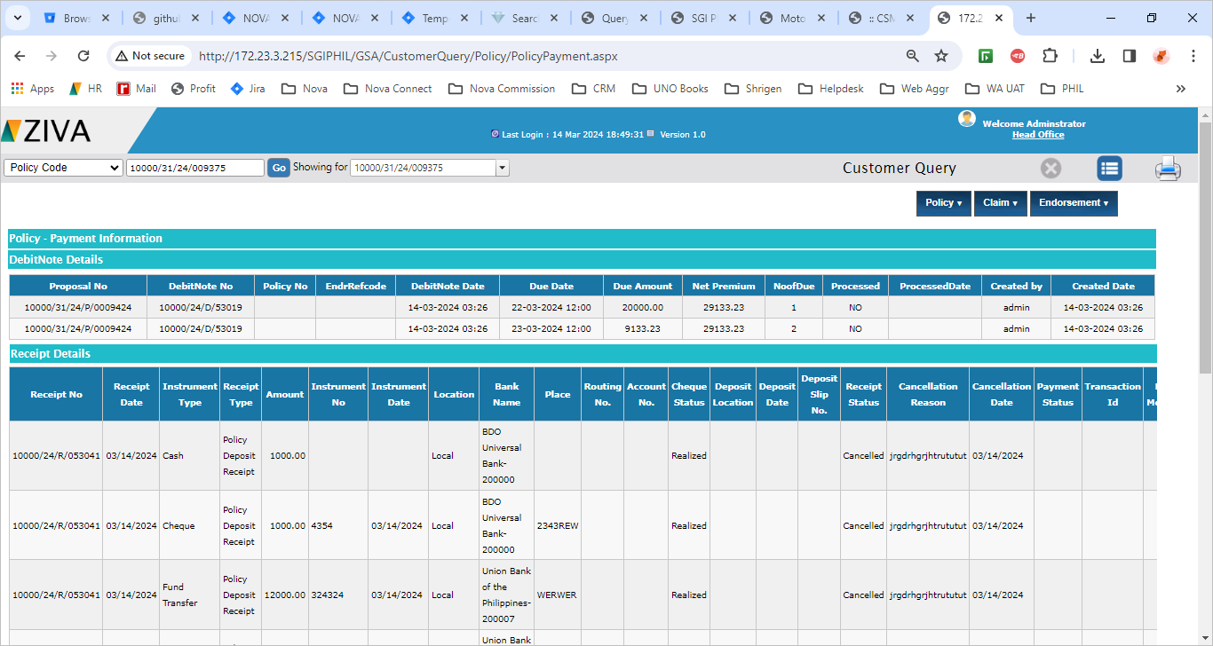

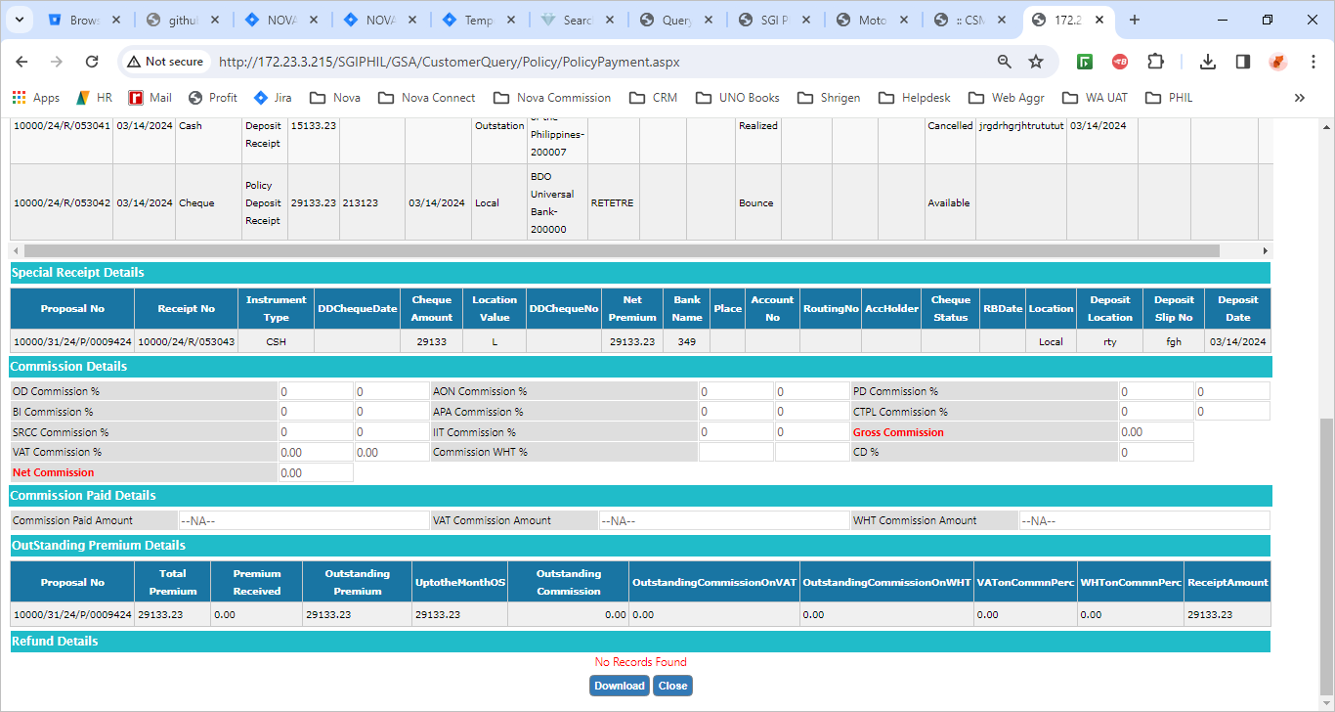

- Claim Information, System should list down the all register claim details against the policy.
- System should list down all claim with the below mentioned details in the Claim Info tab against the respective policy if any, based on the input filter criteria. System should display the below details in the grid format

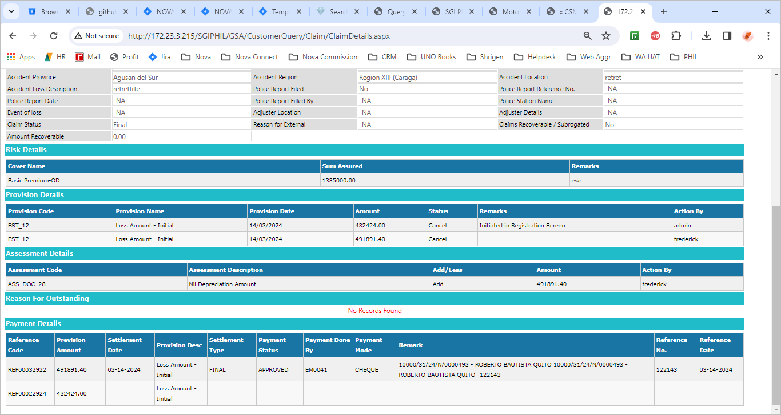

Click on close(X) button symbole to close the window.

